Path-\\10.101.8.106\d$-software-cyberoamclient

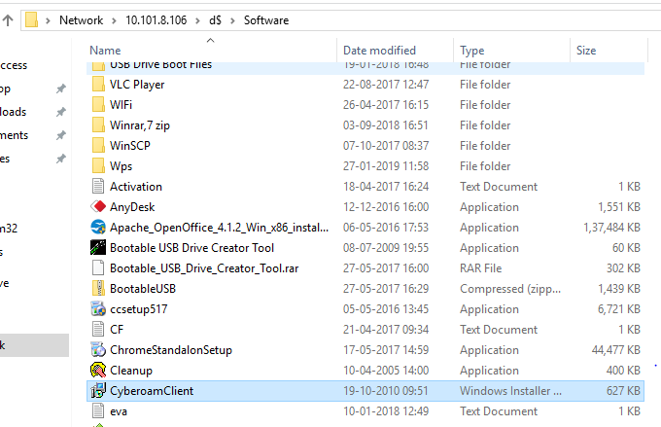

1. Run “cyberoamclient.msi” file

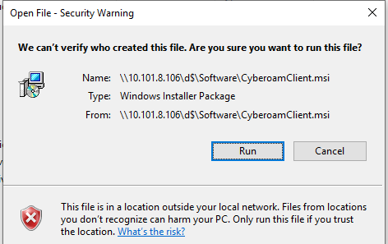

1. Click on “Next tab”

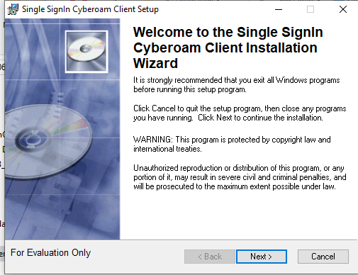

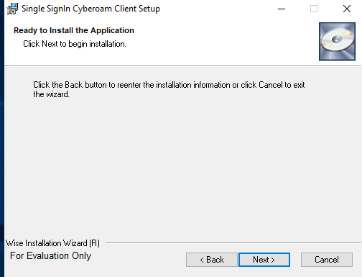

1. Finish the process

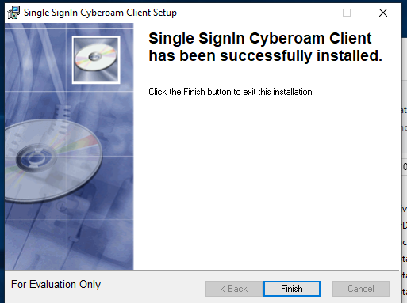

1. Go to start menu and click “single SignIn Cyberoam client”

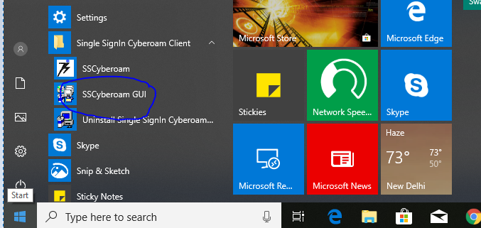

1. Click “SSCyberaom GUI “and add below server ip-10.101.5.5 and domain name-serwizsol.com i.e mention on below snap. And then click “OK”

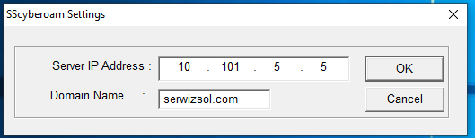

1. After all process done click to ”SSCyberom”

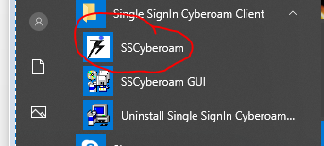

Done.